SMART ENERGY METER FOR DOMESTIC USAGES

A project report submitted in partial fulfillment of the requiremnets for the award of the Degree of

BACHELOR OF TECHNOLOGY
In
ELECTRONIC AND COMMUNICATION ENGINEERING

Submitted
By
1. SUDEEP B S - BU21EECE0100524
2. LAKSHMAN B H - BU21EECE0100553
3. DARSHAN D M – BU21EECE0100574

Under the Guidance of
Dr. P SUNDARARAMAN
Assistant Professor



DEPARTMENT OF ELECTRICAL, ELECTRONICS AND COMMUNICATION ENGINEERING
GITAM SCHOOL OF TECHNOLOGY
GITAM
(Deemed to be University)
(Estd. u/s 3 of the UGC act 1956 & Accredited by NAAC with “A++” Grade)
BENGALURU-561203
AY:2021-2025

DECLARATION
I/We declare that the project work contained in this report is original and it has been done by me under the guidance of my project guide.

Date:
NAME | REGISTER NUMBER | SIGNATURE
SUDEEP B S | BU21EECE0100524
LAKSHMAN B H | BU21EECE0100553
DARSHAN D M | BU21EECE0100574

Department of Electrical, Electronics and Communication Engineering
GITAM School of Technology, Bengaluru-561203



CERTIFICATE
This is to certify that (Sudeep B S , Lakshman B H, Darshan D M) bearing (BU21EECE0100524,BU21EECE0100553,BU21EECE0100574:)has satisfactorily completed Capstone Project “SMART ENERGY METER FOR DOMESTIC UASAGES ”in partial fulfillment of the requirements as prescribed by University for VIII th semester, Bachelor of Technology in
“Electrical, Electronics and Communication Engineering” and submitted this report during the academic year 2024-2025

[Signature of the Guide] [Signature of HOD]

Project Guide Head of the Department

Dr. P Sundararaman

Associate Professor

Dept of EECE
Table of contents
Chapter 1: Introduction 1
  - Overview of the problem statement 1
  - Objectives and goals 1
Chapter 2 : Literature Review 2
Chapter 3 : Strategic Analysis and Problem Definition 3
  - SWOT Analysis 3
  - Project Plan - GANTT Chart 3
  - Refinement of problem statement 3
Chapter 4 : Methodology 4
  - Description of the approach 4
  - Tools and techniques utilized 4
  - Design considerations 4
Chapter 5 : Implementation 5
  - Description of how the project was executed 5
  - Challenges faced and solutions implemented 5
Chapter 6:Results 6
  - outcomes 6
  - Interpretation of results 6
  - Comparison with existing literature or technologies 6
Chapter 7: Conclusion 7
Chapter 8 : Future Work 8

References 9

Chapter 1

Introduction

  - Overview of the problem statement
As the demand for electricity continues to grow, efficient energy management has become a top priority for both utility providers and consumers. Traditional electricity meters, while functional, fall short in providing real-time insights into energy consumption, leading to inefficient energy use, delayed billing, and missed opportunities for cost savings. With the rise of smart technologies and the Internet of Things (IoT), the concept of a Smart Energy Meter offers a revolutionary solution to these challenges.

The Smart Energy Meter Project introduces an innovative system that not only records electricity consumption in real time but also communicates this data seamlessly between consumers and utility providers. By integrating Advanced Metering Infrastructure (AMI) and IoT, the system allows for enhanced monitoring, control, and management of energy usage. This technology enables both residential and commercial users to track their electricity consumption, optimize their usage patterns, and reduce overall costs by leveraging dynamic pricing models based on real-time data.

  - Objectives and goals
    - Real-Time Monitoring: Offer real-time insights into energy consumption, helping users to understand and optimize their energy usage patterns.
    - Reduction in Human Efforts: Automate the billing process by sending data directly to utility providers, eliminating the need for manual meter readings and reducing billing errors.
    - Improved Grid Resilience: Support the resilience of the energy grid by sending predictive maintenance alerts, which help to identify and address potential issues before they lead to power outages.
    - Data Security and Integrity: Ensure secure data transmission to protect the integrity and confidentiality of energy usage data, preventing unauthorized access and ensuring privacy for consumers.

Chapter 2

Literature Review

A Review on Smart Meter System, Umang Patel, Mitul Modi (December 2015). This paper explores the possibility of a smart energy grid in India. Smart energy grid would require smart energy meters. It discusses the current energy meters and their working as well as use of digital, accurate meters for better data measurement, storage and transmission. It talks in detail about how Smart grid is not a device but a conglomeration of different measurement, storage and data transfer techniques such as use of GSM, Zigbee, WIMAX and WLAN. It further talks about the working of all these technologies in details and compares them against one another. Finally, it concludes with the infrastructural requirements for a large scale Smart Grid. We refer this paper for development of smart meter based on GSM.

Design and construction of a smart electric metering system for smart grid applications: Nigeria as a case study Ezeodili Echezona Ugonna, Adebo King Ademola, Akinbulire Tolulope Olusegun (July 2018). This paper starts with the importance of efficient energy distribution and measurement of power consumption accurately and their role in economy of a nation. Then it moves towards the evolution of energy meters into smart energy meters. It gives construction of a meter but not in detail. It briefly talks about the use of different technologies for data transfer such as GSM, Radio frequency etc. The study about metering of energy can help us understand about the details of the energy measurement grid and help in making appropriate features in our project.

Development of Indigenous Smart Energy Meter adhering Indian Standards for Smart Grid, Sreedevi V S, Prakash Prasannan, Jiju K, Indu Lekshmi J I (May 2020). This paper talks about smart metering grid across the world and how it can be implemented in India according to Indian standards. It talks about many innovations in the existing meter such as remote data collection, remote payment of bills, sending consumption details to consumers. It also talks about the challenges to Smart Metering in India such as economic considerations on the consumer side before buying a smart meter and gives different techniques to reduce the cost 4 ` of meter production to make it affordable. The techniques given in this paper to reduce the cost of manufacturing, such as multi layered PCB, can prove useful to our project in future.

GSM-Based Smart Energy Meter with Arduino Uno, Win Adiyansyah Indra, Fatimah Bt Morad, Norfadzlia Binti Mohd Yusof, Siti Asma Che Aziz (March 2018) This paper interfaces a Arduino Uno with a energy meter. This does not give any details about measurement of energy, it directly moves to interfacing of Arduino with energy meter. Next it interfaces GSM with Arduino Uno. GSM is used to send monthly SMS to user to show their bill and energy consumption. The code given in this paper is useful to us in this project. Interfacing of Arduino and GSM is also useful to us.

IOT Based Smart Energy Meter for Efficient Energy Utilization in Smart Grid. Bibek Kanti Barman, et al. This paper explains how Arduino IDE software is used to calculate the pulse of an energy meter via optocoupler. It also has excellent power theft detection. The IoT concept can also be implemented in various working environments such as home automation, automatic water level detector and traffic control system etc.

IoT Based Smart Energy Metering System for Power Consumers. Md. Mohitul Haque et al. This shows us that the IoT based energy metering system has been devised with ADE7758 energy measurement IC. GUI (Graphical user interface) is used here to monitor the system. Constructional details given in this paper can be used to make a smart meter. It can help to manufacture a low-cost meter

A new IoT-based smart energy meter for smart grids, Danielly B. Avancini et al. The authors in this paper use an SG method to monitor, control, and protect energy generation, transmission, and distribution systems in an economical way. Implementation of smart meters is done by IOT Middleware. It can also be used to send wireless information using IOT middleware and other components.

A Smart Meter Design Implemented with IOT Technology, Chang-Pei Yi et al. The authors in the paper focuses on the architecture design of the monitoring and servo terminals, to perform power calculations instantly when the signal is received. In future this can be used for spontaneous calculation of the received signal for better understanding on the power consumption.

Design and Implementation of IoT Based Smart Energy Meter. Saikat Saha et al. This paper talks about how Arduino UNO is more feasible to use than raspberry pi and how to reduce overall costing of the meter. It uses an Arduino UNO with an embedded Wi-Fi module for easy connection. Use of the IOT based concept makes it more versatile for the future of domestic power rating meters.

Chapter 3

Strategic Analysis and Problem Definition

SWOT Analysis

Strengths
    - Real-Time Monitoring and Data Collection:
The smart energy meter provides continuous real-time data on energy consumption. This empowers users to track their energy usage patterns, identify inefficiencies, and make adjustments to save on electricity costs.

IoT Integration and Remote Access:
By utilizing IoT technology, the smart energy meter allows users to remotely monitor and control their electricity consumption via mobile apps or web dashboards.

Reduction in Manual Effort
Automated data collection and transmission reduce the need for manual meter readings, lowering operational costs for utility providers and minimizing human error in billing.

Weaknesses
    - High Initial Installation Costs:
The upfront cost of implementing smart meters can be high, particularly in large- scale deployments across entire neighborhoods or cities. This cost includes the hardware, communication infrastructure, and software systems for data management.

Integration with Legacy Systems:
Many energy grids and utility companies still rely on traditional metering systems, making it difficult to seamlessly integrate new smart meter technologies. Upgrading existing infrastructure to support smart meters may require additional investment and resources.

Complexity in System Setup and Maintenance:
Although the system provides advanced functionality, the integration of IoT, AMI, and dynamic pricing features adds complexity. Ensuring the system operates smoothly may require specialized technical expertise, both during installation and ongoing maintenance.

Dependency on Internet Connectivity:
Since the smart energy meter relies on IoT for real-time data transmission, the system’s performance is heavily dependent on a stable internet connection. In areas with poor connectivity, data transmission may be delayed or interrupted, reducing the effectiveness of the system.

Opportunities
    - Growing Demand for Energy Efficiency:
As both residential and commercial consumers become more conscious of their energy consumption and its environmental impact, there is a growing market for energy-saving solutions like the smart energy meter.

Regulatory Support for Smart Grid Technologies:
Governments and regulatory bodies worldwide are pushing for the adoption of smart grid technologies to improve energy efficiency and sustainability. Incentives, subsidies, and mandates to upgrade grid infrastructure create opportunities for smart energy meter deployment on a large scale.

Expansion into Developing Markets:
Many developing countries are rapidly expanding their energy infrastructure. The introduction of smart meters in these regions offers an opportunity to build smarter, more efficient grids from the start, avoiding the need for costly upgrades in the future.

Data-Driven Energy Management Solutions:
The data collected by smart meters can be used for more than just billing. Utility providers can analyze consumption data to better understand demand patterns, optimize grid performance, and design energy-saving programs. Consumers, too, can leverage this data to optimize their energy use and reduce costs.

Threats
    - Data Security and Privacy Concerns:
As smart energy meters collect detailed data on consumers’ electricity usage, the system becomes a target for cyberattacks. Unauthorized access to this data could lead to privacy breaches, exposing sensitive information about consumers' activities. Ensuring secure data transmission and storage is essential to mitigate this threat.

Technological Obsolescence:
The rapid pace of technological advancement in the IoT and energy sectors may render current smart meter models outdated within a few years. Staying ahead of technological changes and ensuring compatibility with future smart grid systems could be challenging and costly.

Resistance to Change from Consumers and Utility Providers:
Some consumers and utility providers may resist the adoption of smart energy
meters due to concerns about cost, privacy, or perceived complexity.

Competing Technologies:
The market for smart energy management systems is highly competitive, with various technologies and solutions being developed by different companies. Competitors may offer similar features at lower prices or introduce new innovations that outperform existing systems, posing a threat to market share.

Regulatory and Policy Changes:
Changes in government regulations, such as shifts in energy policy or the introduction of new industry standards, could impact the adoption and implementation of smart meters. Companies must remain agile and compliant with evolving regulations to stay competitive.

  - Project Plan - GANTT Chart

Abstract
The project team spent the month of July working on creating a abstract that would include the study's goals, approaches, and anticipated results. This abstract will direct further effort and provide a succinct overview of the work completed.

Literature Survey

The Team spent Half a Month for the Literature survey that would include finding research papers, conference papers and some key findings of the project.

Components identification

The team works and went through all the Necessary components Required for project and How to use that components.

Program Building

The Team Spent a Month For program Building for this project since we are using esp32 board it requires program.

Report and Poster Making
The Team started making the poster and Report from march onwards and it includes all the details about the project.
Project submission (

In the end, we produced a thorough report to highlight the project that we spent so much time working on, as well as a poster presentation that provided a clear and concise display of our project's concept, execution, and results.

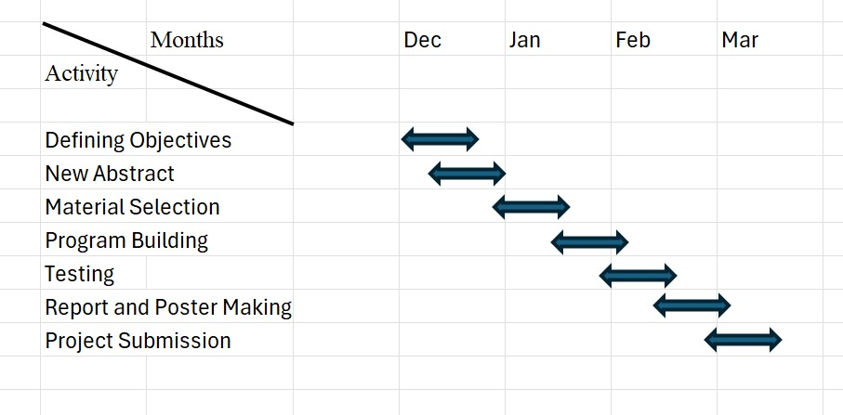

  - Refinement of problem statement

The refined objectives of the Smart Energy Meter project aim to enhance the functionality and utility of the energy management system, addressing the evolving needs of both consumers and utility providers in residential and commercial energy monitoring.

Continuous Improvement:
The smart energy meter will be designed to evolve continuously, with updates based on data analysis and feedback from consumers and utility providers. This ensures that the system remains efficient and adaptable to changing energy consumption patterns, technology advancements, and regulatory standards.

User Engagement and Education:
The system will incorporate user-friendly interfaces and tools that educate consumers on optimizing their energy consumption. This includes detailed insights into usage patterns, guidance on energy-saving practices, and adapting the interface based on individual user preferences and requirements. This engagement is critical for encouraging energy-saving behaviors and enhancing user satisfaction.

Scalability and Integration:
The project will focus on designing a scalable smart meter system that can be easily integrated into various energy grids, from small residential areas to large commercial operations. The system will accommodate the diverse needs of different energy providers and regions, ensuring compatibility with existing infrastructure and future energy sources, including renewables like solar and wind power.

Security and Data Privacy:
The smart meter will be developed with strong data security and privacy measures to ensure that all energy consumption data remains confidential and secure. This includes encrypted communication channels and compliance with data protection regulations to safeguard consumer information.
By addressing these refined objectives, the Smart Energy Meter Project will significantly improve energy efficiency, optimize billing, enhance consumer engagement, and strengthen grid reliability. The system will contribute to global energy conservation efforts while supporting a sustainable and smart energy future.

Chapter 4

Methodology

4.1 Description of the approach

In the energy sector, efficient management of electricity usage is crucial for both consumers and utility providers. Smart energy meters address the challenges of traditional energy monitoring by offering real-time data, dynamic pricing models, and enhanced grid resilience. The system integrates Advanced Metering Infrastructure (AMI) with IoT capabilities to provide comprehensive energy usage insights, automate billing processes, and support the stability of the energy grid

The project focuses on the development and implementation of a Smart Energy Meter System, designed to enhance energy monitoring, reduce wastage, and empower users to manage their energy consumption effectively. The system is equipped with sensors to measure electricity usage, data transmission modules to communicate with utility providers, and remote monitoring capabilities for consumers.

Challenges in Traditional Energy Management:
    - Manual Meter Readings: Traditional meters require human intervention, leading to possible errors in billing and delays in energy usage reports.

    - Lack of Real-Time Data: Consumers are unaware of their energy consumption patterns until the billing cycle is complete, missing opportunities for energy-saving measures.
    - Static Pricing Models: Fixed rates don't incentivize users to shift consumption to off-peak hours, leading to inefficient energy usage.
    - Grid Reliability: Without real-time monitoring, power outages or equipment failures can disrupt supply, resulting in inefficiencies for utility providers.

Technology Selection:
When developing the Smart Energy Meter, selecting the appropriate technology is critical for ensuring reliable data collection, seamless communication, and user-friendly interfaces.
- Accuracy of Measurement: The meter must be equipped with high-precision sensors to provide accurate data on electricity usage, voltage, current, and power factor.
- Connectivity Options: The meter should offer stable and secure connectivity solutions, such as Wi-Fi or 4G/5G, to facilitate real-time communication between consumers and utility provider.

- Power Efficiency: The meter itself should consume minimal power to maintain efficient operation, particularly in locations where power supply is limited.

Selected Components for the Smart Energy Meter:
- Energy Monitoring Sensors:
  - Voltage Sensor
  - Current Sensor
  - Power Factor Measurement
These sensors record detailed energy consumption data for residential or commercial setups, enabling precise billing and energy usage analysis.

Communication Module:
  - Wi-Fi/4G Module: This module ensures continuous and secure data transmission between the energy meter and the central control system (cloud or utility provider's server). IoT integration allows real-time data monitoring and access from remote devices.

Communication Setup for Data Transmission:
- Data Transmission:
A secure communication protocol (e.g., MQTT, HTTP) is employed for data transmission from the smart meter to a cloud platform or utility server. This ensures that all energy consumption data is sent in real-time, enabling immediate monitoring by both consumers and utility providers.

Data Security:
Encryption mechanisms (e.g., TLS, SSL) are implemented to protect sensitive consumer data during transmission. This ensures the confidentiality and integrity of energy data, preventing unauthorized access.

Dynamic Pricing and Alert Systems:
- Dynamic Pricing:
The smart meter can support dynamic pricing models, where energy prices fluctuate based on demand. By analyzing consumption patterns, the system can provide consumers with real-time recommendations on when to use energy during off-peak hours to reduce costs.

Alert System for Faults and Overuse:
The system will be equipped with an alert feature that notifies consumers of potential issues, such as abnormally high consumption or faults in electrical equipment. This will enable early intervention, reducing the risk of overloads or outages[5].

Testing, Validation, and Regulatory Compliance:
- Rigorous Testing:
The smart meter undergoes extensive testing under simulated and real-world conditions to validate its performance. This includes stress tests for handling high
and low voltage, accuracy testing for energy measurement, and network stability tests for continuous communication.

Field Trials:
Collaboration with utility providers for field trials will help gather real-world feedback on system performance, identify areas of improvement, and ensure that the meter functions effectively in diverse environments

Regulatory Compliance:
The smart meter must meet industry standards for energy metering and data security, including IEC or IEEE standards for electrical devices. Compliance with these standards ensures the meter’s accuracy, reliability, and safety for deployment in various regions

  - Design considerations

- ESP32 Development Board:
The ESP32 is a powerful and versatile microcontroller with built-in Wi-Fi and Bluetooth capabilities, making it a key component for IoT applications like the Smart Energy Meter.

Control Pins:
    - EN (Enable Pin): This pin is used to enable the chip. It must be pulled HIGH to keep the chip operational, and pulling it LOW will reset the microcontroller, which is useful for restarting or resetting the system.
    - RST (Reset Pin): The RST pin is used to reset the ESP32 manually. Connecting this pin to the ground will reboot the microcontroller, restarting its processes.

Analog Pins (ADC):
    - ADC1 & ADC2 (Analog-to-Digital Converter): The ESP32 has 18 ADC pins, which are divided into two groups (ADC1 and ADC2), capable of measuring analog voltage in the range of 0-3.3V. These pins are crucial for reading data from sensors such as voltage, current, or power sensors used in the Smart Energy Meter.
      - ADC1 Pins: GPIO32, GPIO33, GPIO34, GPIO35, GPIO36, GPIO37, GPIO38, GPIO39.
      - ADC2 Pins: GPIO0, GPIO2, GPIO4, GPIO12, GPIO13, GPIO14, GPIO15, GPIO25, GPIO26, GPIO27. The ESP32's ADC can be used to
sample energy consumption data or monitor voltage fluctuations in real time.

Digital Pins:

The ESP32 has 34 GPIO (General Purpose Input/Output) pins, which can be used for

digital input/output, controlling sensors, relays, or other peripherals. These GPIO

pins are programmable and can be configured for multiple

functions.

4. SPI (Serial Peripheral Interface) Pins:
    - The ESP32 supports SPI communication, which is essential for high-speed communication with peripherals like displays or external memory.

SPI Pins:
        - MOSI (GPIO23)
        - MISO (GPIO19)
        - SCLK (GPIO18)
        - CS (GPIO5)

5. I2C (Inter-Integrated Circuit) Pins:
    - The ESP32 supports I2C communication, which allows multiple sensors to be connected with fewer wires. This is particularly useful in IoT applications where compact wiring is important.

Default I2C Pins:
        - SDA (Data Line): GPIO21
        - SCL (Clock Line): GPIO22 This interface is commonly used for connecting power monitoring sensors, voltage/current sensors, or display modules.

UART (Universal Asynchronous Receiver-Transmitter) Pins:
    - The ESP32 has three UART interfaces that support serial communication, making it easy to interface with external devices like other microcontrollers, PCs, or GPS modules.
      - UART0: TX (GPIO1), RX (GPIO3)
      - UART1: TX (GPIO10), RX (GPIO9)
      - UART2: TX (GPIO17), RX (GPIO16)

PWM (Pulse Width Modulation) Pins:
    - The ESP32 features PWM functionality on most GPIO pins, which is used to control components like LEDs, motors, or other devices that require variable power input. PWM can also be used in advanced energy management applications.

Wi-Fi and Bluetooth Connectivity:
    - One of the ESP32’s standout features is its dual Wi-Fi and Bluetooth (v4.2) support, which enables the Smart Energy Meter to send energy data in real- time to cloud platforms or utility providers via Wi-Fi, and potentially interface with other devices through Bluetooth. This makes the ESP32 ideal for seamless communication and remote monitoring in IoT-based energy systems.

Power Management:
    - The ESP32 offers low-power consumption modes that are essential for applications where energy efficiency is critical, such as battery-powered systems or remote energy monitoring devices. The power-saving modes, such as deep sleep and light sleep, ensure that the system consumes minimal energy when not actively processing data.

Touch Capacitive Pins:
- The ESP32 has 10 capacitive touch GPIO pins, which can be used to create touch- sensitive interfaces. This can be an added feature for user interaction in future versions of the Smart Energy Meter, enabling control or feedback through touch input.

Communication Protocols:
- MQTT/HTTP:
  - The ESP32 supports both MQTT (Message Queuing Telemetry Transport) and HTTP protocols, allowing efficient data transmission between the smart meter and the cloud or utility provider servers. MQTT is lightweight and suited for IoT applications, ensuring reliable communication even with limited bandwidth.

TLS/SSL Security:
  - To secure data transmission, the ESP32 supports TLS/SSL encryption, ensuring that the energy consumption data is transmitted securely over the network. This is critical for protecting user data and maintaining system integrity.

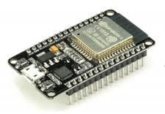

Current Sensor (SCT-013)
SCT-013-000 is a Non-Invasive AC current sensor i.e. it is a current transformer that can be used to measure AC current up to 100 amperes. [9] This non-invasive current sensor clamped around the supply line can measure a load up to 30 Amps, and allow you to calculate how much current pass through it. [10] It can be useful for building your own energy monitor or for building an overcurrent protection device for an AC load.

Technical Specifications:
Operation Table 1 - Technical specifications of SCT 013

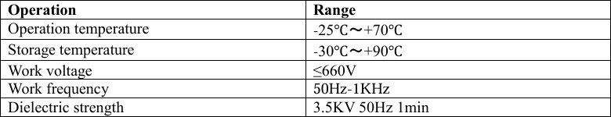

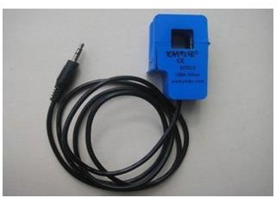
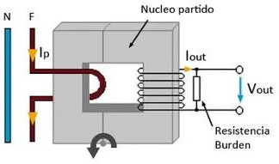

They operate by magnetically inducing current from the conductor they are placed on into a proportional electric current that flows through the CT conductors. They make it possible for power meters to measure current on circuits that, if they measured the current directly, would overpower the meters. If you want to monitor power, you need to use CTs.

Voltage Sensor (ZMPT101B)
The ZMPT101B is an AC voltage sensor module that can measure AC voltages. Its output is analog and varies as the input voltage changes. The module uses a resistive voltage divider circuit-based DC voltage sensing device to generate an analog output. [12] ZMPT101B AC Voltage Sensor is the best for the purpose of the DIY project, where we need to measure the accurate AC voltage with a voltage transformer. [13] This is an ideal choice to measure the AC voltage using Arduino/ESP8266/Raspberry Pi like an open source platform.

Technical Specifications:

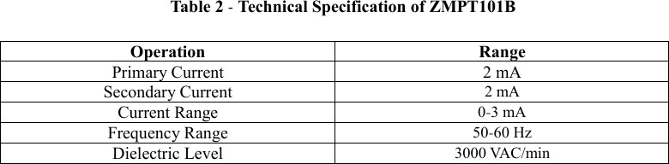

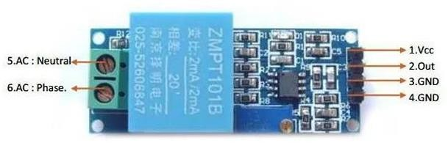

Circuit diagram

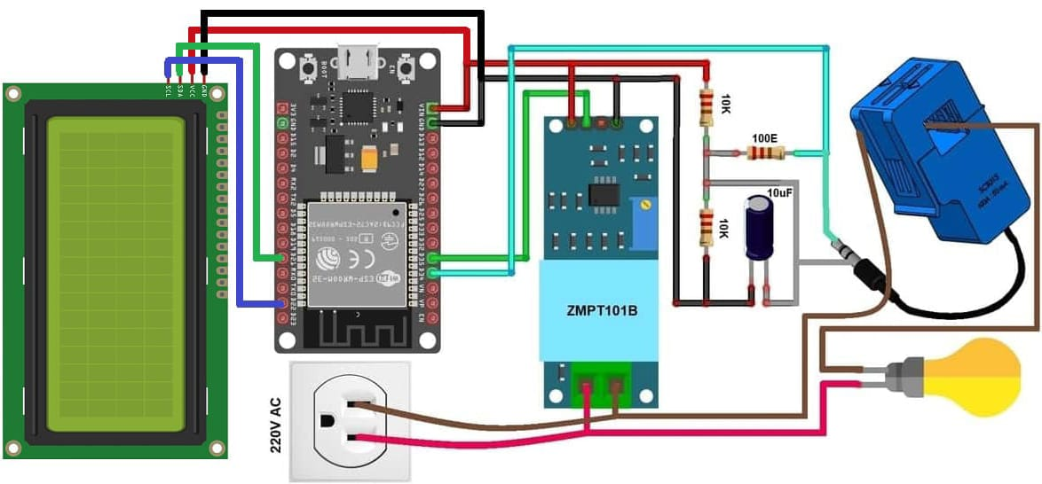

Blynk App Implementation
Step 1: Search for blynk.io in the website.

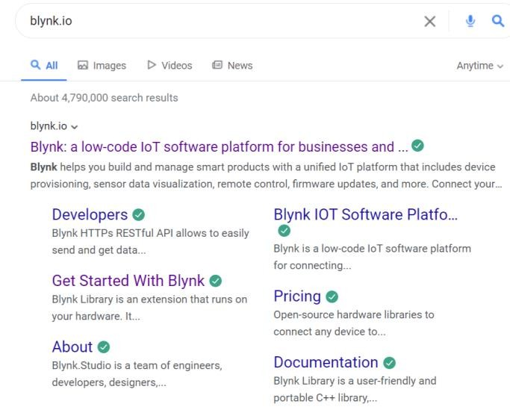

Step 2: Click on the first link and the Blynk cloud online will open.



Step 3: Create an Account in the Blynk.

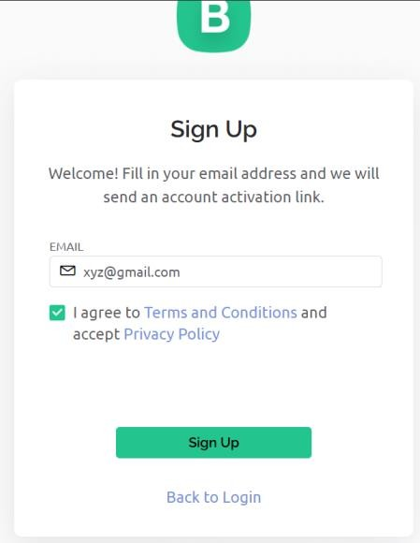

Step 4: After login, go to the devices and create a folder where you can create wedges.
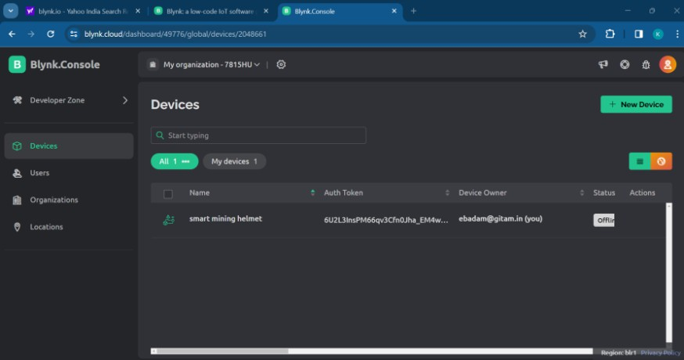

Step 5: Enter the token id required for the code.
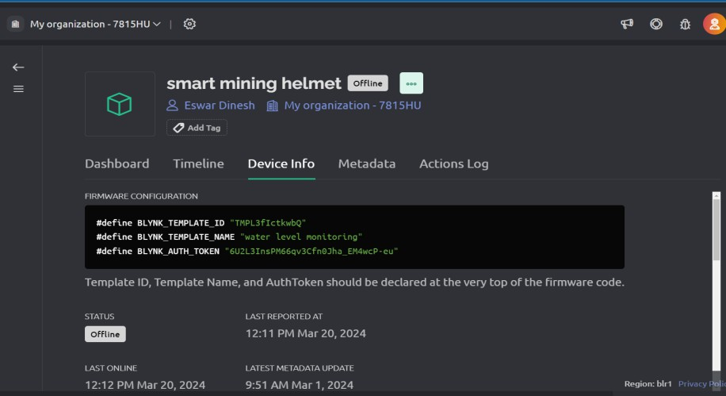

Step 6: Install the Blynk app in the phone.

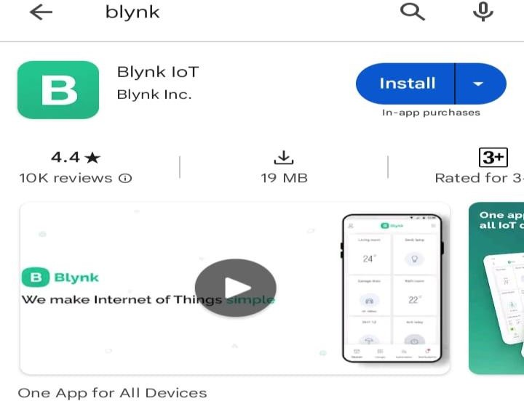

Step 7: Select the folder which was created on Blynk.

Step 8: Create the Wedges for different sensors output.

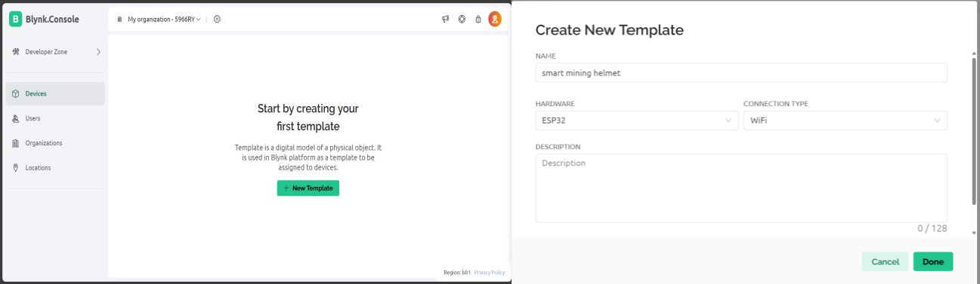

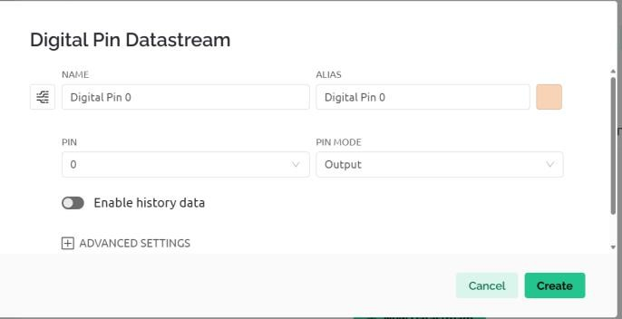
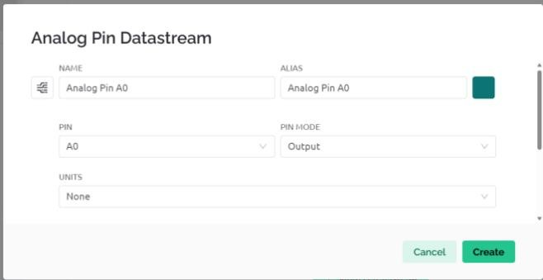

Step 9: The output of the sensors will be visible on the cloud (Blynk App)

Design Considerations
Design considerations for the Smart Helmet System in the mining industry encompass various aspects crucial for its effectiveness and practicality.
    - Firstly, robustness and durability are paramount. The helmet must withstand harsh mining environments, including extreme temperatures, moisture, dust, and physical impacts. Selecting materials and components capable of enduring these conditions is imperative to ensure longevity and reliability.
    - Secondly, ergonomics and comfort are vital for user acceptance and compliance. The helmet should be lightweight, well-ventilated, and adjustable to accommodate different head sizes comfortably for prolonged wear. Additionally, integrating the sensor technology seamlessly without compromising comfort is essential to prevent hindrance to the wearer's movements and tasks.
    - Thirdly, sensor accuracy and reliability are critical for the system's efficacy. The selected sensors must offer precise measurements of gas levels, temperature, humidity, and proximity to hazards. Calibration procedures should be established to maintain sensor accuracy over time, ensuring

dependable data for timely hazard detection and alert generation.

    - Moreover, power efficiency is essential to prolong battery life and minimize downtime for recharging or replacement. Efficient power management strategies, such as low-power sensor modes and intelligent battery monitoring, should be implemented to optimize energy consumption without sacrificing system performance.
    - Furthermore, data transmission and communication protocols should prioritize reliability and low latency to enable real-time monitoring and response. Robust wireless connectivity options compatible with underground environments.
    - Lastly, compliance with safety regulations and industry standards is non-negotiable. The Smart Helmet System must adhere to relevant safety guidelines and certifications to guarantee its effectiveness in mitigating risks and protecting miners. Regular audits and updates to align with evolving safety standards are essential to maintain the system's effectiveness and regulatory compliance.

Chapter 5

Implementation

  - Description of how the project was executed
- Project Planning and Preparation: The project commenced with meticulous planning, including defining project objectives, scope, and resource allocation. Through research paper consultations we conducted to gather requirements and ensure alignment with Public needs. A project plan was developed, outlining timelines, milestones.
- Research and Technology Selection: Extensive research was conducted to identify suitable sensor technologies and components. Factors such as accuracy, reliability, and compatibility with Electrical environments were considered. Collaborations with academic advisors facilitated informed decision-making during the technology selection process.

- Design and Development: The project proceeded with the design and development of the Smart Energy Meter. This phase involved creating system architecture, hardware prototyping, sensor integration and software interface design. Iterative development cycles were employed to refine the system's functionality and address technical challenges.
- Testing and Validation: Rigorous testing was conducted to validate the performance and reliability of the Smart Energy Meter System. Simulated mining environments were used to assess sensor accuracy, durability, and communication effectiveness. Feedback from testing informed iterative improvements and ensured compliance with safety standards.

- Prototyping and Iterative Development: The project adopted an iterative development approach, starting with the creation of prototypes to validate concepts and functionality. Feedback from initial prototypes guided subsequent iterations, allowing for continuous improvement and refinement of the Smart Helmet System
- Implementation and Deployment: Following successful testing, the Smart Energy Meter was implemented in real time data operations. Deployment involved adjusting the helmet on system usage, maintenance procedures, and emergency button output.
- Monitoring and Evaluation: Post-deployment, the project team monitored the performance of the Smart Energy Meter. Data on hazard detection, response times, and user feedback were
collected and analyzed to evaluate the system's effectiveness in enhancing safety and productivity.

  - Challenges faced and solutions implemented

During the development and implementation of the Smart Energy Meter, several technical and operational challenges were encountered. Addressing these challenges was critical to ensuring the system’s reliability, accuracy, and overall effectiveness in both residential and commercial energy monitoring.
Challenges:
    - Data Accuracy and Sensor Calibration:
In energy monitoring systems, ensuring accurate measurement of voltage, current, and power consumption is critical. Small inaccuracies can lead to incorrect billing, misreporting, or inefficient energy management. Calibrating the sensors to achieve the highest possible precision posed a significant challenge, especially in real-time monitoring conditions where data transmission and collection must happen simultaneously.
    - Power Management for Continuous Operation:
The smart energy meter is designed to operate continuously, requiring reliable power management. Ensuring that the meter consumes minimal energy while maintaining real-time data transmission was a challenge, particularly in regions where energy outages or fluctuations are common. The meter itself had to consume less power while operating its sensors, microcontroller, and communication modules.
    - Wireless Communication Reliability:
The Smart Energy Meter relies heavily on continuous communication with cloud servers or utility providers for real-time monitoring and control. Maintaining a reliable wireless connection, especially in areas with poor internet connectivity, was challenging. Dropped signals or intermittent data transmission could disrupt real-time monitoring and lead to delays in updating usage information.
    - Data Security and Privacy:
Given the sensitive nature of electricity consumption data, ensuring secure data transmission was a critical challenge. Unauthorized access or tampering with energy data could lead to privacy breaches or manipulation of energy bills. The system had to be designed with strong encryption protocols to protect the integrity and confidentiality of the data.
    - Integration with Legacy Infrastructure:
Many existing energy grids and utility companies use traditional meters and infrastructure, making it challenging to integrate a modern, IoT-enabled system like the smart energy meter. Ensuring compatibility with older systems required overcoming technical limitations, such as differences in communication protocols and grid management practices.
    - Dynamic Pricing Models:
Implementing dynamic pricing requires accurate and up-to-date data on energy usage patterns
and real-time electricity rates. Integrating this feature and ensuring that users can take advantage.

Solutions Implemented:
- Sensor Calibration and Accuracy Enhancements:
To ensure accurate measurement of electricity usage, the sensors used in the smart energy meter were calibrated at various stages of development. Regular calibration routines were implemented, along with error correction algorithms to filter out noise or inaccuracies. Testing under different load conditions helped ensure that the sensors provided reliable data across a range of operational environments[4].
- Low Power Consumption Design:
Power optimization was achieved by using energy-efficient components like the ESP32, which has multiple low-power modes (deep sleep and light sleep). These modes were utilized during idle periods, reducing overall power consumption. Additionally, the sensors and communication modules were programmed to activate only when necessary, further extending the system’s operational life in case of power fluctuations.
- Enhanced Communication Protocols:
To address communication reliability issues, the MQTT protocol was employed, which is lightweight and designed for reliable communication in low-bandwidth environments. Failover mechanisms were also built into the system, allowing data to be temporarily stored locally on the device during network outages and transmitted once the connection was restored. This ensured that no data was lost during intermittent connectivity.
- Data Encryption and Security:
The system was equipped with TLS/SSL encryption to secure all data transmissions between the smart meter and cloud servers or utility provider servers. This ensured that the energy consumption data remained private and protected from unauthorized access. In addition, secure authentication mechanisms were implemented to ensure that only authorized personnel or systems could access the data.
- Backward Compatibility with Legacy Systems:
The smart energy meter was designed to work alongside existing infrastructure by using standard communication protocols like Modbus and RS485, which are widely used in traditional systems. This allowed the smart meter to communicate with older systems, ensuring smoother integration into existing grid management operations.
- Implementation of Dynamic Pricing:
A dynamic pricing feature was implemented by incorporating real-time data analytics into the cloud platform. The smart meter continuously monitors energy consumption patterns and adjusts pricing based on peak and off-peak hours. Utility providers were consulted to synchronize pricing updates with the meter, allowing consumers to take advantage of lower electricity rates during off-peak times, thereby reducing overall energy costs.

Chapter 6

Results
  - Outcomes
The integration of the Smart Energy Meter system with cloud-based platforms has led to multiple positive outcomes, significantly enhancing energy management, operational efficiency, and grid stability. This section provides detailed insights into these outcomes.
Enhanced Energy Monitoring and Management:
The primary goal of the Smart Energy Meter was to revolutionize energy consumption monitoring for residential and commercial users. By integrating sensors for voltage, current, and power factor measurement with real-time data transmission to a cloud platform, users and utility providers gain advanced tools to monitor energy consumption patterns and take action accordingly.
    - Real-Time Monitoring: The Smart Energy Meter continuously records and reports energy consumption in real-time, enabling users to observe their usage patterns and reduce wastage. This information is transmitted seamlessly to the utility provider’s server, offering insights into demand fluctuations and system performance[1].
    - Remote Control and Monitoring: By leveraging IoT capabilities, the Smart Energy Meter allows users to remotely monitor their energy consumption and receive alerts if usage exceeds preset thresholds. This enables consumers to make data-driven decisions, reduce their energy bills, and shift their consumption to off-peak times for cost savings.
    - Dynamic Pricing: The system supports dynamic pricing models by tracking consumption in real-time and notifying users when energy costs are lower during off-peak periods. This helps users take advantage of cost-saving opportunities while also contributing to grid stability by reducing peak demand pressure.
Increased Operational Efficiency:
The integration of real-time data analytics with cloud-based platforms has also increased operational efficiency for utility providers.
    - Automated Meter Reading: The Smart Energy Meter eliminates the need for manual meter reading by transmitting usage data directly to the utility provider's server. This not only reduces labor costs but also minimizes the potential for human error in billing, improving accuracy and timeliness.
    - Anomaly Detection: The system is designed to detect anomalies in energy consumption, such as unusually high usage or equipment malfunctions. Alerts are automatically sent to the user or utility provider, enabling quick corrective action and preventing costly disruptions.
    - Grid Resilience: The Smart Energy Meter improves grid resilience by providing predictive maintenance insights. In case of potential system overloads or equipment failures, the system can notify utility providers, helping them prevent outages and manage the energy supply more efficiently.

  - Interpretation of results

The successful development and deployment of the Smart Energy Meter have demonstrated its capability to enhance energy management and grid resilience.
Energy Consumption Monitoring:
The meter’s sensors, which accurately measure voltage, current, and power factor, provide continuous, real-time insights into energy usage. This data enables both consumers and utility providers to make informed decisions, such as optimizing energy consumption during peak and off- peak hours. The ability to monitor consumption remotely adds convenience for consumers and encourages them to actively participate in energy-saving initiatives[7].
Dynamic Pricing and Cost Savings:
One of the most significant outcomes of the Smart Energy Meter is its integration with dynamic pricing models. Consumers can shift their energy usage to off-peak hours when rates are lower, leading to substantial cost savings. By reducing peak demand, utility providers can also manage the energy supply more efficiently, contributing to the overall stability of the energy grid.
Enhanced Grid Stability:
The Smart Energy Meter helps utility providers monitor grid conditions in real time, identify potential issues, and take corrective action before outages occur. Predictive maintenance features allow utility providers to plan repairs or upgrades to equipment based on usage patterns and system performance, reducing downtime and enhancing the grid’s reliability.

  - Comparison with existing literature or technologies

Technologies Sensor Comparison:
- Current and Voltage Sensors:
  - Existing Technology: Current and voltage sensors provide accurate readings of energy usage, which are crucial for calculating total power consumption. These sensors are reliable and cost-effective, making them suitable for both residential and commercial energy monitoring.
  - Alternative Technology: Advanced energy monitoring systems can use more sensitive sensors, such as Hall Effect sensors, to increase the precision of current measurement, especially for industrial-scale monitoring.
- Power Factor Measurement:

  - Existing Technology: Power factor measurement in the Smart Energy Meter allows users to monitor energy efficiency and reduce wastage. By maintaining a high power factor, consumers can avoid unnecessary surcharges from utility providers.
  - Alternative Technology: Other energy meters integrate more complex algorithms for analyzing power quality, including harmonics, which are critical in industrial settings to ensure smooth operation of machinery.
- Real-Time Data Transmission:
  - Existing Technology: The Smart Energy Meter transmits data in real-time using secure communication protocols, such as MQTT or HTTP, ensuring that users and utility providers receive instant updates on energy consumption[3].
  - Alternative Technology: Some systems employ LoRaWAN (Low Range Wide Area
Network), which offers longer-range communication at a lower bandwidth, making it ideal for remote or rural areas with limited internet connectivity.

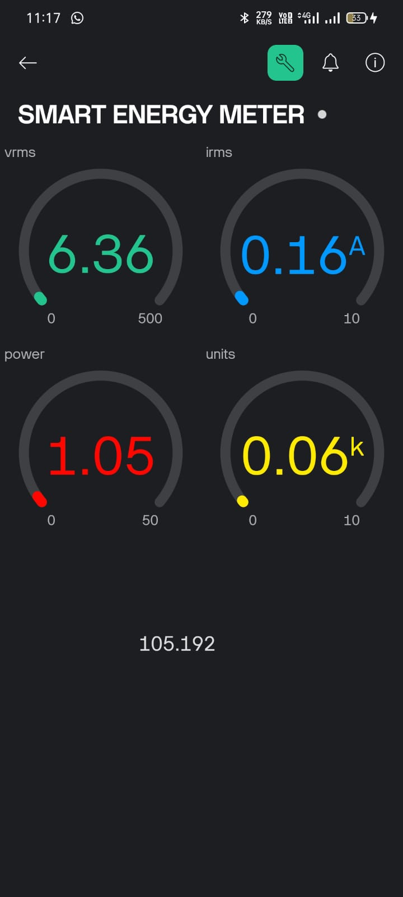
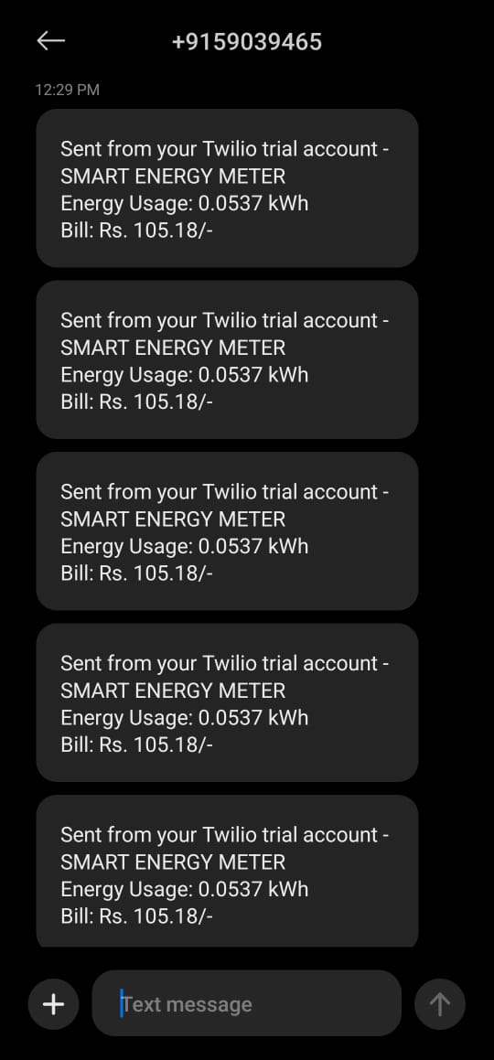

Cloud Platform Comparison:
- Blynk IoT:
  - Advantages: Blynk is ideal for rapid prototyping and small-scale IoT projects, offering ease of use with a drag-and-drop interface[2]. It is suitable for users who want quick integration of smart meters with mobile applications.
  - Limitations: It may not be as scalable for large utility providers managing thousands of devices.
- AWS IoT:
  - Advantages: AWS IoT provides robust scalability, security, and a wide array of tools for data analytics, making it ideal for large-scale smart grid applications. Its integration with other AWS services allows for advanced analytics and machine learning capabilities.
  - Limitations: AWS IoT may require more advanced technical knowledge for setup and management.
- Google Cloud IoT:
  - Advantages: Google Cloud IoT excels in machine learning and predictive analytics, which can be beneficial for analyzing energy consumption trends and improving grid management.
  - Limitations: It may have higher operational costs, especially for smaller-scale projects.
Conclusion on Technology Comparison:
Each cloud platform and sensor technology offers unique advantages, and the choice of system depends on the specific requirements of the deployment. For residential and small-scale commercial applications, Blynk IoT is a practical and cost-effective option. For large utility providers, AWS IoT or Google Cloud IoT may provide the scalability and advanced analytics needed for managing

Chapter 7: Conclusion

In conclusion, the Smart Energy Meter Project represents a significant advancement in modernizing energy management for residential, commercial, and industrial applications. By integrating advanced metering infrastructure (AMI) with real-time data analytics and IoT capabilities, the project offers a comprehensive and forward-thinking solution for efficient energy utilization, cost savings, and enhanced grid resilience.
The smart energy meter enables continuous monitoring of energy consumption, empowering users to make informed decisions about their electricity usage and encouraging more sustainable consumption patterns. By supporting dynamic pricing models, the system allows consumers to benefit from off-peak electricity rates, ultimately reducing their energy costs while alleviating stress on the energy grid during peak demand periods.
Furthermore, the real-time transmission of data to utility providers enhances grid management by providing early warnings of potential outages, enabling predictive maintenance, and improving overall grid stability. The integration of secure communication protocols ensures the confidentiality and integrity of energy data, safeguarding consumer privacy and maintaining system reliability.
The Smart Energy Meter Project highlights the crucial role that technology plays in fostering a more energy-efficient and sustainable future. As we continue to face growing demands for electricity, solutions like this will be essential in driving global energy conservation efforts, reducing carbon footprints, and promoting long-term economic and environmental sustainability.
By empowering consumers with real-time insights into their energy usage and improving the operational efficiency of utility providers, this project marks a pivotal step towards a smarter, more resilient, and eco-friendly energy infrastructure. Continued research and development will further enhance the capabilities of smart energy meters, ensuring their widespread adoption and impact on global energy management.

Chapter 8 : Future Work

As we look to the future, several avenues can be explored to enhance and expand the capabilities of the Smart Energy Meter system, driving innovation in energy management and furthering the impact on energy efficiency, sustainability, and grid resilience.
- Global Adaptation and Customization:
The Smart Energy Meter can be adapted to suit the unique regulatory and infrastructure requirements of different regions across the globe. Tailoring the system to accommodate
diverse grid architectures, renewable energy integration, and local energy policies will facilitate wider adoption. Customization can also account for variances in energy consumption patterns, electricity pricing models, and climate conditions, ensuring the system remains effective in various contexts.
- Integration with Smart Grid and Energy Management Systems:
Integrating the Smart Energy Meter with broader smart grid technologies and energy
management systems can enhance operational efficiency. By combining real-time energy data from the meter with other data sources—such as renewable energy inputs or demand-side management systems—utility providers can gain a holistic view of grid performance and optimize energy distribution more effectively. This could lead to improved load balancing, better management of distributed energy resources (DERs), and enhanced demand response strategies.
- Collaboration with Renewable Energy Systems:
Expanding the Smart Energy Meter’s functionality to support renewable energy sources such as solar and wind will empower consumers to monitor and manage their self-generated
energy. Integrating real-time monitoring of renewable inputs and energy storage systems (e.g., batteries) will allow users to optimize their energy use by switching between grid-supplied and renewable energy based on real-time data, maximizing energy savings and reducing environmental impact.
- Enhanced Communication Protocols:
Implementing advanced communication protocols such as LoRaWAN, NB-IoT, or 5G can improve the system’s ability to operate in remote areas or regions with unstable internet connectivity. Additionally, ensuring secure and encrypted communication channels will protect sensitive energy data and prevent unauthorized access, strengthening both consumer privacy and grid security.
- Advanced Analytics and Machine Learning Integration:
Leveraging predictive analytics and machine learning algorithms will allow the system to identify patterns in energy consumption and predict future energy needs. By analyzing historical and real-time data, the system could offer personalized recommendations to consumers on how to reduce energy usage or shift consumption to off-peak times. For utility

- Dynamic Pricing Models and Consumer Incentives:
Further refinement of dynamic pricing models can help users optimize energy costs by responding to real-time price fluctuations. Enhancing these models to include additional pricing incentives for energy-saving behaviors, such as participating in demand response programs or using energy during off-peak hours, can encourage more sustainable consumption patterns. Collaboration with energy providers to offer tailored incentives will help expand the system’s value for consumers[6].
- User Interface and Experience Optimization:
Improving the user interface and user experience is key to ensuring that consumers can easily interpret energy data and take meaningful actions. Future iterations of the Smart Energy Meter could include more intuitive dashboards, mobile app enhancements, and better data visualization tools. Conducting user feedback sessions and usability testing will help identify areas for improvement in terms of design, functionality, and ease of use.
- Scalability for Large-Scale Deployment:
To support large-scale deployment, the Smart Energy Meter system can be designed for scalability. Ensuring that the system can handle millions of data points, users, and devices across residential, commercial, and industrial sectors will be critical for adoption at the utility level. This includes optimizing data storage, processing, and real-time analytics capabilities to handle massive datasets efficiently.
- Field Testing and Validation:
Extensive field testing in various geographical and operational environments will provide valuable feedback on the system’s performance, reliability, and user satisfaction. Testing the meter in real-world conditions will help identify areas for improvement, ensuring that the system meets the diverse needs of both consumers and utility providers.

References

[1]Amanpreet Kaur[etal], "Design and Implementation of Smart Energy Meter using IoT," International Journal of Advanced Research in Electrical, Electronics and Instrumentation Engineering, Vol. 7, No. 4, April 2018.

[2]B. Sunil Kumar[etal], "IoT-based Smart Metering and Load Control using ESP32," International Journal of Engineering Research & Technology (IJERT), Vol. 8, No. 6, June 2019.

[3]Ritesh Bendre[etal], "Smart Energy Meter using IoT," International Journal of Innovative Research in Electrical, Electronics, Instrumentation, and Control Engineering, Vol. 6, Issue 3, March 2018.

[4]Y. Wang[etal], "Energy Management and Optimization using IoT-enabled Smart Meters, "IEEE Internet of Things Journal, Vol. 5, No. 3, March 2018.

[5]D. Zeng[etal], "Real-Time Energy Management System based on IoT-enabled Smart Metering," IEEE Transactions on Industrial Informatics, Vol. 13, No. 6, June 2017.

[6]K. G. Chan[etal], "Dynamic Pricing Models for IoT-enabled Smart Meters in Residential Energy Systems," Journal of Renewable Energy Systems, Vol. 9, No. 2, February 2021.

[7]R. Patel[etal], "IoT-Based Smart Energy Meter with Real-Time Data Analytics, "International Conference on Smart Grid and Energy Management (SGEM), 2020.

